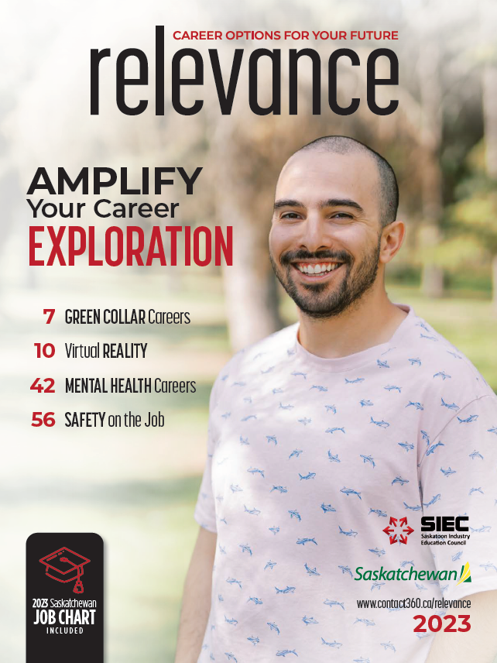

Relevance 2023: Amplify Your Career Exploration
This guide is designed with teachers and students in mind but can be used by anyone who is discovering what this year’s edition of Relevance offers. Teachers, please tailor this document to meet the needs of your unique classes.
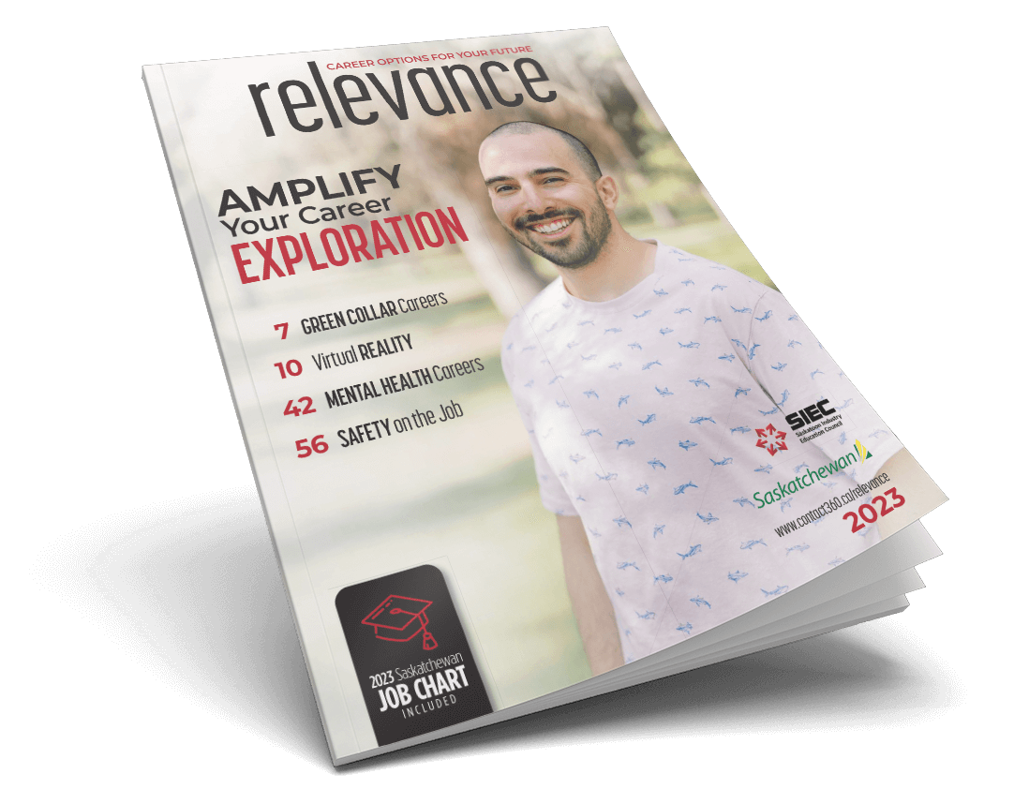
Introduction
On pages 2 and 3, readers are given some quick snapshots of what to expect in the magazine. Note the five themes and read the advice provided for each. Which piece of advice do you relate to the most?

Peer Profiles: Teachers, choose which option (A, B, or C) best suits your class.
In Relevance 2023, you will find eight interviews with young professionals from Saskatchewan (pages 6, 8, 11, 15, 44, 47, 48, 52). These workers are not that far removed from being a student like you.

Option A
After reading through the eight Peer Profiles, respond to each question (1-5) by referring to a different profile for each answer:

- Which person had the most unique career path? Briefly describe this career journey.
- What are the three pieces of advice that you find the most helpful? From three separate profiles, list:
- The person’s name.
- The advice they give.
- Why you find this advice helpful and/or interesting.
- a. If you were an employer, which of these people would you hire?
- What qualities make this person a potentially great employee?
- a. Which of these people works in an industry that is most interesting to you?
b. What is the industry?
c. Why is it interesting to you?
- a. Which of the industries are you least likely to be involved in?
- Why isn’t this a good fit for you?
Option B (Teachers, you could assign all or just some of these questions).

- Reid Patterson, page 6.
  - Why does Reid find his current occupation satisfying?
  - How did Reid choose his master’s program?
  - When asked for advice about job hunting, Reid states, “Use your network.” What does he mean by this, and how could his advice apply to your future career path?

- Tiffany Martinka, page 8.
  - How did Tiffany’s initial post-secondary pathway change? What can you learn from this?
  - Aside from caring for her family, how did Tiffany create meaningful work during the COVID pandemic?
  - Being a farmer is not the only career pathway in agriculture. Search online for five other interesting occupations that you could have in agriculture. HINT: Technology can play a BIG role in ag careers these days!

- Rene Dufour-Contreras, page 11.
  - What are two important steps Rene took to start his career journey?
  - Why is lifelong learning an important part of Rene’s current work?
  - Even if you do not think you will work directly in the technology sector like Rene, what is one piece of advice that he gives that you can apply to your life?

- Cree Angel Duquette, page 15.
  - Based on Cree Angel’s responses, what would it be like to be an Aircraft Maintenance Engineer?
  - What are two moments that led to Cree Angel discovering her career path?
  - Cree Angel says that her parents and grandparents surviving residential school is “fuel to fight for [her] dreams.” What lesson can you learn from this?

- Kiana Henderson, page 44.
  - How do you think travelling can help a person discover a fulfilling career path?
  - Kiana says, “You need to work on yourself before you can help others.” Why might this advice be important for a mental health and addictions counsellor?
  - Kiana’s job can be stressful. What are three things she does to ensure she is taking care of herself?
  - What are two positive things that you do to relieve stress?

- Logan Larlham, page 47.
  - Logan received advice that “university is an investment.” There are many different types of post-secondary training that you can choose from. How is post-secondary education an investment in your future?
  - Logan studied vaccine development but has had different types of science-based occupations in his career so far. What lesson can you learn from this that might apply to your future career path?
  - Logan states, “In science, you have to be proactive about finding opportunities for yourself.” Why can this advice be helpful for anyone, even if they are not in a science-based career?

- Victoria Gagné, page 48.
  - Victoria says that she struggled with imposter syndrome.
    - What is imposter syndrome? You can research this answer, but use your own words to define this term.
    - How might a person overcome the negative effects of imposter syndrome?
  - Not “being in community” made Victoria’s first job less fulfilling than she wanted, so she looked for a new occupation. What are two important values that you want to be present in your career?
  - When thinking about careers, what does success mean to you?

- Honey Constant-Inglis, page 52.
  - How did Honey overcome her “biggest challenge” at university?
  - Many people think that you can only have one role in your career (e.g. teacher, police officer, lawyer, etc.). How does Honey’s career challenge this belief?
  - How does Honey connect to her Indigenous identity through the different roles she has in her career?

Option C
Get into a small group and your teacher will assign you each one of the Peer Profile or Mentor Profile interviews to research. Read the article and prepare some notes so you can share what you learned with your class.

Guiding Questions:
- Who is the person being profiled?
- What is this person’s current occupation?
- What made this person’s career path unique?
- If you were this person’s supervisor, what qualities make this person a valuable employee?
- What advice does this person provide for young people who are beginning their career path?
- What is one thing that this person’s profile makes each of your group members consider?

Other Articles

- Micro-credentials, page 5. What are Micro-credentials, and how can they be a valuable part of your current or future education?

- Spotlight on “Green Collar” Careers, page 7.
  - What is an enhanced skillset?
  - Which two of the trending green collar jobs interest you and/or are ones you have not heard of?

- Virtual Reality, page 10. VR is affecting many occupations in our province! Imagine an occupation that you would like to have in the future. How might VR help you prepare for this role?

- Tips for Young Workers, page 12. What are two tips that you find helpful?

- Explore Careers in Skilled Trades, page 13.
  - Based on the article, what are three benefits to choosing a career in the skilled trades?
  - Read the article and then look at the Saskatchewan Youth Apprenticeship site. Explore the benefits of the SYA program for students both during and after high school. Write these down or discuss as a class.

- Scholarships & Awards, page 16. Choose one scholarship that you could be eligible for in the future:
  - Who is this scholarship designed for?
  - What are the requirements to apply for that scholarship? (find application form)
  - What do you need to provide in your application form?
  - When is the due date for the award application?

- Spotlight on Mental Health Careers, page 42.
  - Why might a career in mental health services a good choice for a career path?
  - Which of the post-secondary programs would you choose?

- Soft Skills, page 46. Employers often say that they hire people and then teach skills. This means that the soft skills described in this article are highly valued!
  - Which skill mentioned in this article is one you could improve?
  - What can you do to improve this skill?
  - How can improving this skill benefit you in a current or future workplace?

Continued on the following page…

- Job Search: Links to Your Future, page 50. Under each of the four headings, choose a site to explore and consider how each one is useful for people searching for a job. Come together as a class to discuss the sites that were the most helpful.

- Safety is Your Best Friend on the Job, page 56. After reading the article, write down your three basic rights in the workplace. Depending on what you have discussed about safety in class prior to the article, check out at least one of the links to Workplace Safety Resources to learn more about the importance of safety.

Mentor Profiles: Read the profiles of these two professionals who are leaders in their industries. Respond to the questions and discuss what you learned with your peers.

Stacey Szczecinski, page 54.
  - Stacey made a huge decision in her career journey to switch from university to a polytechnic program. Lots of people think that one pathway is their only choice but then discover that there are other options that suit them better. Create a list of advantages for both university and polytechnic programs. Why would each pathway be a good fit for you?
  - Stacey mentions that her work schedule can be “week in, week out or two weeks in and two weeks out.”
    - What does “two weeks in and two weeks out mean”?
    - Many people choose their career based on the lifestyle they would like to have. Some prefer 9-5 jobs; many people like to work remotely (work from home). What are three qualities that you want your future occupation to have to create a positive lifestyle for you?
Ahmad Majid, page 55.
        - Ahmad chose an occupation where he could help others. Is helping others a value that you will search for in your future career? List three occupations that you might like to have and write down how each doesn’t just benefit you, but benefits others as well.

        - Ahmad’s career isn’t just focused on his role at the Saskatchewan Intercultural Association. He is also a hip hop artist and poet. Many people choose a career path that allows them to pursue other passions that they find fulfilling and –sometimes—profitable! Choose one of the occupations you listed in your previous answer. Describe how this occupation would allow you time to pursue another passion. Note: Some people call this a side-hustle if it can be profitable, but it can also be a hobby that you love that takes time and practice.
2023 Job Chart
You will find this section on pages 17-41.
Your task is to choose one job from each of the five following sections (you pick the sections):
- Business, Finance, and Administration
- Natural & Applied Science
- Health
- Social Science, Education, Law, Government, and Religion
- Art, Culture, Recreation, and Sport
- Sales and Service
- Trades, Transport, and Equipment Operation
- Natural Resources, Agriculture, and Related Production
- Processing, Manufacturing, and Utilities
Once you have your five jobs selected, write down the following:
- Job title.
- What do you do in the job?
- Where do you get education/training to do the job?
- One reason why you think you would be good at that job.
Next Step: On page 50, there is a list of job search sites. Access one or more of these links to see what job opportunities are out there for two of the jobs you chose. When you find them, identify a skill that each job requires, and describe how this fits your skill set.

Take this a step further by looking up post-secondary options and details about the type of job on your myblueprint.ca account!

