

***Relevance 2025: Your Future is Limitless***

This guide is designed with teachers and students in mind but can be used by anyone who is discovering what this year’s edition of *Relevance* offers. Teachers, please tailor this document to meet the needs of your unique classes.

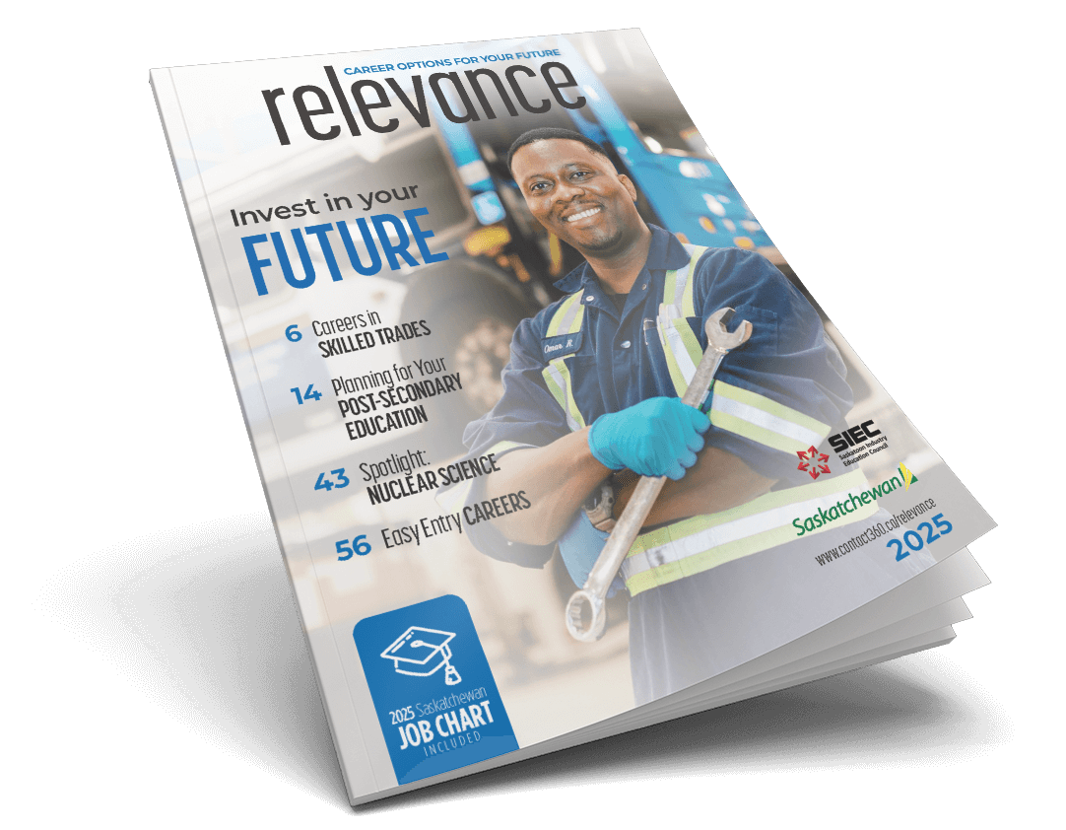**Introduction**

On pages 2 and 3, readers are given some quick snapshots of what to expect in the magazine. Note the five themes and read the advice provided for each. Which piece of advice do you relate to the most?

**Peer Profiles.** Teachers, choose which option (A, B, or C) best suits your class.

In *Relevance 2025*, you will find five Peer Profile interviews with professionals from Saskatchewan (pages 4, 9, 11, 42, and 46). These workers are not that far removed from being a student like you.

***Option A***

After reading through the *Peer Profiles*, respond to each question (1-5). Try to refer to a different profile in each answer when possible:

1. Which person had the most unique career path? Briefly describe this career journey.
2. What are the **three** pieces of advice that you find the most helpful? From three separate profiles, list:
3. The person’s name.
4. The advice they give.
5. Why you find this advice helpful and/or interesting.
6. a. If you were an employer, which of these people would you hire?
7. What qualities make this person a potentially great employee?
8. a. Which of these people works in an industry that is most interesting to you?

b. What is the industry?

c. Why is it interesting to you?

1. a. Which of the industries are you least likely to be involved in?
2. Why isn’t this a good fit for you?

***Option B*** (Teachers, you could assign all or just some of these questions)

1. **Omar Robinson, page 4**. *Hint—You may need to look up the italicized terms!*
   1. Omar says that “becoming a mechanic came naturally” to him. What is something you are skilled at that could become an occupation in your future?
   2. What is a “*journeyperson ticket*”?
   3. What is the difference between an *apprentice* and a *journeyperson*?
   4. What is a “*red seal*” journeyperson?
   5. Why is communication so important in the skilled trades?
2. **Danielle Laroque, page 9**.
   1. What does Danielle enjoy about her work?
   2. What can we learn from Danielle’s pathway though university?
   3. Why did Danielle enjoy Indigenous Studies?
   4. What are two things that influenced Danielle to become a corrections officer?
3. **Ben Scott, page 11**.
   1. Ben’s love of Lego inspired a possible career path. What is a hobby you have that could lead to a possible occupation in your future?
   2. Ben lists six different sectors as possible areas for scientists to work in. What is a specific occupation that a scientist could have in each of these sectors?
   3. Ben recommends networking to students. What does this term mean? How can it benefit someone’s career journey?
4. **Logan Regier, page 42**.
   1. Why can Logan’s career path be described as *non-linear*? Provide some examples in your response.
   2. Logan studied many different post-secondary subjects. Even though some of them didn’t lead directly into a profession, how can studying lots of different subjects benefit a person’s career path?
5. **Shaun Halford, page 46.**
   1. What responsibilities does a *combined lab and x-ray technologist* have?
   2. What influenced Shaun’s choice of post-secondary program?
   3. Shaun says that he “looked at my clinical as a year-long job interview.” What does this mean?
   4. Why are critical thinking and collaboration important in Shaun’s profession?
   5. What is a cyclotron like the one at the Fedoruk Centre in Saskatoon used for?

***Option C***

Get into a small group and your teacher will assign you each one of the *Peer, Business, or Mentor Profiles* to research. Read the article and prepare some notes so you can share what you learned with your class.

**Guiding Questions**:

1. Who is the person being profiled?
2. What is this person’s current occupation?
3. What made this person’s career path unique?
4. If you were this person’s supervisor, what qualities make this person a valuable employee?
5. What advice does this person give people who are beginning their career path?
6. What does this person’s profile make each of your group members consider?

**Business Profile (pages 48-49)**

1. If someone were to ask you what **Rock & Bloom** does, how would you describe this business?
2. Research what responsibilities a person in each of these professions would have at a business like **Rock & Bloom**:

* Account manager
* Sales
* UX strategist

1. Research and write down the difference between a web developer and a web designer
2. What does Heather mean by the term *human capital*?
3. Heather mentions relationships a lot.
   1. Why are positive relationships so important in a profession like Heather’s?
   2. How do you think entrepreneurs build positive relationships with the people they work with?

***Next up: Other Articles***

**Other Articles**

1. **Invest in Your Future, pages 2-3**.
   1. What are two suggestions in this article that you will do to start exploring your future career pathway?
   2. Which quoted piece of advice speaks to you the most? Explain why!
2. **Explore Careers in Skilled Trades, page 6**.
   1. What are three benefits to choosing a career in the skilled trades?
   2. Read the article and then look at the [Saskatchewan Youth Apprenticeship](https://saskapprenticeship.ca/sask-youth-apprenticeship/) site. Explore the benefits of the SYA program for students both during and after high school. Write these down or discuss as a class.
3. **Spotlight on Careers in Corrections, page 8.** 
   1. What do corrections workers do?
   2. What “Typical Jobs” listed in the article are interesting to you?
   3. What do you need to do to get a job in corrections?
   4. Follow the link in the article and list what types of corrections jobs are available in Saskatchewan right now.
4. **What does the Saskatchewan Labour Market Strategy mean for students?**

**page 10.** According to this article, what advantages are there in choosing to complete your post-secondary career training in Saskatchewan?

1. **9+1 Skills for Success, page 13**.
   1. Which skill mentioned in this article is one you could improve?
   2. What can you do to improve this skill?
   3. How can improving this skill benefit you in a current or future workplace?
   4. Which skill in this article is one of your strengths?
2. **Planning Your Post-Secondary Education, page 14**.
   1. What is affiliated or federated college? Research what an advantage of choosing to attend one of these colleges could be.
   2. What is a credential that you might like to achieve one day?
   3. Which credential are you most unfamiliar with?
   4. In what ways can this article help someone who is planning post-secondary training in Saskatchewan?
3. **Scholarships & Awards, page 16**. Choose one scholarship that you could be eligible for in the future:
   1. Who is this scholarship designed for?
   2. What are the requirements to apply for that scholarship? (find application form)
   3. What do you need to provide in your application form?
   4. When is the due date for the award application?
4. **Spotlight: Careers in Nuclear Science, page 43.** 
   1. What differences are there between the “3 Paths to a Nuclear Career”?
   2. What roles could a person have if they choose to work in Nuclear Science?
5. **Focus on Safety, page 50**.
   1. What is one of the “Top Workplace Distractions for Young People” that you had not considered before? Why would this distraction be a safety issue at work?
   2. What tips are given to lower the stress you might feel at a new job?
   3. List your three rights in the workplace.
6. **Will AI Replace Human Work?, page 52**.
   1. What is AI?
   2. Some people worry that AI might replace humans at work. What reasons are there to disagree with this opinion?
   3. In a world where AI is present, what skills can you build in so you can have a fulfilling career?
7. **9 Easy Entry Careers, page 56.**
   1. What is a career in this article that you are least familiar with?
   2. What is one career in this article that might suit your skills and/or interests?

***Next up: Mentor Profiles***

**Mentor Profiles:** Read the profiles of these two professionals who are leaders in their industries. Respond to the questions and discuss what you learned with your peers.

**Dr. Chris Scribe, page 54**.

* + - * 1. a. How many different roles has Dr. Scribe had during his career?

b. What can you learn about the potential direction of your career path after reading about his journey?

* + - * 1. Working in education led Dr. Scribe to starting Indigenous-focused businesses. Think of something in your life that you value—perhaps based on your family or culture. What is a potential profession or business that you could have where your culture or values would be an important part of your work?
        2. a. Who were Dr. Scribe’s role models?

b. What role did his role models play in his career journey?

c. Who is someone who will likely have a positive influence on your future career path?

* + - * 1. We often think of people with doctor as their title as being doctors of medicine. What is Chris a doctor of? How did he earn this title?

**Ashala Naidu, page 55**.

* 1. How can travelling overseas after high school positively impact a person’s career pathway? Ashala mentions at least two benefits. Try to come up with two or three more on your own or with a friend.
  2. Ashala mentions that it takes 6-7 years of university to become a lawyer. With a friend, create a list of the benefits of spending that much time in post-secondary school. How many can you come up with?
  3. Ashala is both a lawyer and an entrepreneur.
     1. Aside from being a lawyer, what is a profession that requires a lot of training, but where a person can be an entrepreneur at the same time?
     2. Considering the profession that you chose above, create a chart where you list the benefits and the challenges of being both a professional and an entrepreneur.

***Next up: Job Chart***

**2025 Job Chart**

*You will find this section on pages 17-41.*   
  
**Your task is to choose five jobs that interest you. Choose one job from five of the following sections (you pick the sections):**

1. 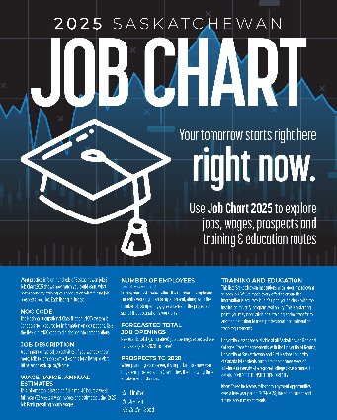Business, Finance, and Administration
2. Natural & Applied Science
3. Health
4. Social Science, Education, Law, Government, and Religion
5. Art, Culture, Recreation, and Sport
6. Sales and Service
7. Trades, Transport, and Equipment Operation
8. Natural Resources, Agriculture, and Related Production
9. Processing, Manufacturing, and Utilities

**Once you have your five jobs selected, write down the following**:

1. Job title.
2. Describe this job.
3. Where do you get education/training to do the job?
4. One reason why you think you would be good at that job.

**Next Step: On page 45, there is a list of job search sites**. Access one or more of these links to see what job opportunities are out there for **two** of the jobs you chose. When you find them, identify a skill that each job requires, and describe how this fits your skill set.

**Take this a step further** by looking up post-secondary options and details about the type of job on your *myblueprint.ca* account!