

Relevance 2026: Celebrating the PAST, Inspiring the FUTURE
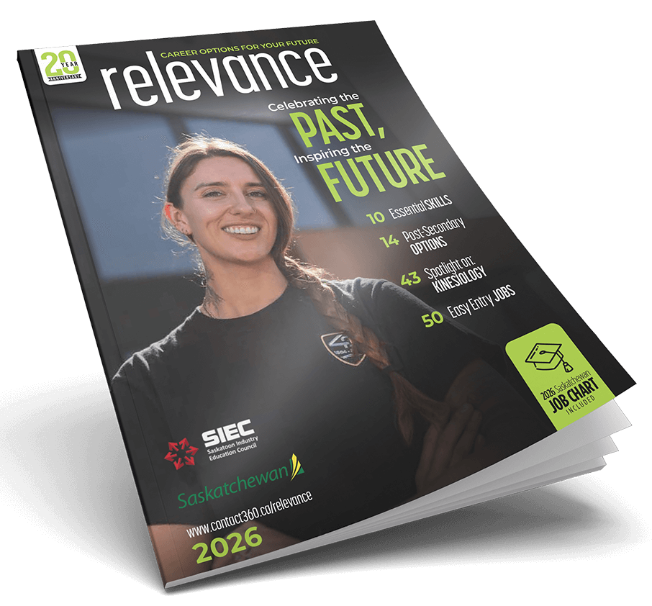
This guide is designed to help educators engage students in exploring Relevance 2026: Celebrating the PAST, Inspiring the FUTURE. Through discussion, reflection, and career exploration activities, students will connect with Saskatchewan professionals, learn about diverse pathways, and discover how their strengths and interests can shape their future. Teachers are encouraged to adapt these activities to fit the needs and interests of their students.

Introduction

On page 2, readers are introduced to this year’s theme, Celebrating the Past, Inspiring the Future.
On pages 3–5, you meet six professionals who were featured on past Relevance covers. Each person shares an update on their career path, lessons they’ve learned, and advice for students.

Discussion Questions:

- Which of the six professionals’ updates did you find most inspiring or relatable? Why?
- What similarities or differences do you notice among their career journeys?
- What advice could help guide your own education or career decisions?

Peer Profiles:

Teachers, select the option (A, B, or C) that best suits your class.

In Relevance 2026, you will find five Peer Profile interviews featuring Saskatchewan professionals. These individuals share unique stories of growth, change, and perseverance as they navigate their careers.

Option A

After reading through the Peer Profiles, respond to each question (1-5). Try to refer to a different profile in each answer when possible:

- Which person had the most unique career path? Briefly describe their journey.
- What are three pieces of advice that you found most helpful?
For each, list the person’s name, the advice they give, and why you find it meaningful.
- If you were an employer, which of these individuals would you hire?
What qualities make them a great candidate?
- Which industry discussed is most interesting to you, and why?
- Which industry feels least aligned with your interests? Explain your reasoning.

Option B (Teachers, you could assign all or just some of these questions)

Charity Karcha – page 6
Red Seal certified Auto Body Technician and instructor at Saskatchewan Polytechnic
- What first sparked Charity’s interest in the auto body trade?
- What does Charity enjoy most about her career in auto body repair and restoration?
- How does teaching allow Charity to share her experience and give back to her industry?
- What advice does Charity offer to students, especially women, considering a career in the skilled trades?
- How does Charity’s story show that careers in the trades can also be creative and rewarding?

Kelly Paul – page 12
Industrial Millwright and Maintenance Supervisor at Cameco’s Cigar Lake
- What kinds of tasks do an industrial millwright perform, and where do they typically work?
- What led Kelly to choose a hands-on career in the skilled trades?
- What parts of his job does Kelly find most rewarding?
- What does Kelly’s story show about finding success through on-the-job learning and apprenticeship?
- What advice does Kelly share for people who are thinking about entering a trade or starting an apprenticeship?

Kellie Towriss – page 42
Pharmacist and co-owner of a dance and baton studio
- What inspired Kellie to pursue careers in both pharmacy and dance?
- What does Kellie enjoy most about each of her roles?
- How do both of Kellie’s careers allow her to help and connect with people?
- What does Kellie’s story teach about following more than one passion in your career?
- Why is it important to explore all your interests when planning your future career path?

Scott Van Breda – page 52
Medical Radiologic Technologist
- What did Scott enjoy about working in the business and finance sector?
- What made Scott decide to change careers and move into health care?
- What does Scott enjoy most about his new career as a Medical Radiologic Technologist?
- What does Scott’s story show about the possibility of changing direction later in life?
- What advice does Scott share for students who are still exploring their future career options?

Raj Thankore – page 55
Practice Lead for Networking & Securing at ESTI Consulting Services
- How did Raj’s early interest in video games influence his choice to pursue a career in technology?
- What brought Raj to Saskatchewan, and how did this move shape his career opportunities?
- How has Raj advanced and grown within the technology field over time?
- What does Raj enjoy most about his work in networking and cybersecurity?
- What are his thoughts on how artificial intelligence may affect computer networking careers?

Option C

Working in small groups, each group will be assigned to one of the Peer, Business, or Mentor Profiles. Read the article, discuss what you learned, and present a summary to the class using these questions:

- Who is being profiled, and what is their current role?
- What makes their career journey unique?
- What advice do they offer for students beginning their own path?
- What qualities or values make this person successful?
- What advice does this person give to people who are beginning their career path?
- What does this person’s profile make each of your group members consider?

Next up: Business Profile

Business Profile: Rise Air (pages 46-47)

- If someone were to ask you what Rise Air does, how would you describe this business and the services it provides in Saskatchewan?
- Rise Air operates throughout northern Saskatchewan.
  - Why is air transportation so important for northern and remote communities?
  - How does Rise Air help connect people, goods, and services across the province?
- Working in aviation can present both challenges and rewards.
  - Which parts of this work do you think are the most challenging?
  - Which parts do you think are the most rewarding?
- Safety is a top priority for Rise Air.
  - Why is safety especially important when flying in northern and remote regions?
  - How does it shape the way Rise Air operates every day?
- Rise Air emphasizes community connection and service.
  - How does this company contribute to the communities it serves beyond transportation?
  - What personal qualities would make someone a good fit for working in the aviation industry?

Next up: Other Articles

Other Articles

What’s New in Skilled Trades? – page 8
- Why are careers in the skilled trades considered in demand, and how do they offer strong earning potential and career mobility?
- How are skilled trades careers likely to remain important even as AI changes the world of work?
- After reading, visit the Saskatchewan Youth Apprenticeship (SYA) website. What are two benefits of joining SYA in high school?

Workplace Safety – page 9
- What are some of the common safety risks young or new workers might face on the job?
- The article emphasizes the importance of awareness. What does that mean when it comes to staying safe at work?
- What are your three basic rights as a worker in Saskatchewan, and how can understanding them help you stay safe and confident in a new workplace?

Building Essential Skills – page 10
- Which of the essential skills do you already use at school or in daily life?
- Which skill would you most like to improve? How could you practice it?
- Why do employers value lifelong learning, and how can you continually build your skills?

Curious About Your Post-Secondary Options? – page 14 – 15
- What are some of the different post-secondary pathways available in Saskatchewan?
- How do colleges, universities, and polytechnics differ in the types of programs and learning experiences they offer?
- How does this article help you think about planning your education or training after high school?

Scholarships & Awards – page 16
Choose one scholarship that you could be eligible for in the future:
- Who is this scholarship designed for, and what are the main eligibility requirements?
- What documents or information do you need to include in your application?
- When is the application due, and what steps can you take now to prepare?

Spotlight on Kinesiology Careers – page 43
- What types of careers are available to someone with a kinesiology background?
- Which kinesiology-related role sounds most interesting to you, and why?
- How does kinesiology connect to health, sport, and community wellbeing?

Job Search Sites in Saskatchewan – page 44
- What are two websites mentioned in the article where you can explore job opportunities in Saskatchewan?
- Visit one of these sites and find a job posting that interests you. What qualifications or skills does it ask for?
- What could you start doing now to prepare for that type of position?

Spotlight on Automotive Careers – page 49
- How is technology, including electric vehicles, changing the automotive industry and the work technicians do?
- What is the difference between the roles of an Automotive Service Technician and an Auto Body & Collision Technician?
- What technical and personal skills are important for success in today’s automotive industry?

11 Easy Entry Jobs – page 50
- Which job listed best matches your current skills or interests?
- What training or experience could help you get started in that role?
- How can easy entry jobs serve as a first step toward a larger career goal?

Job Search Tips – page 51
- What is one piece of job search advice from this article that you found most useful?
- How can networking or volunteering help you find opportunities?
- Why is a positive attitude important during the job search process?

How to Thrive in the Age of AI – page 53
- How can you learn to use artificial intelligence positively and ethically in school or the workplace?
- What AI tools do you currently use, and which new tools could you incorporate to support learning or future career goals?
- Some careers are more resilient to AI than others. Which types of careers do you think will always need a human touch, and which interests you most?

Next up: Job Chart

2026 Job Chart

You will find this section on pages 17 – 41
Your task is to choose five jobs that interest you.
Choose ONE job from five of the following sections (you pick the sections):


- Business, Finance, and Administration
- Natural & Applied Science
- Health
- Social Science, Education, Law, Government, and Religion
- Art, Culture, Recreation, and Sport
- Sales and Service
- Trades, Transport, and Equipment Operation
- Natural Resources, Agriculture, and Related Production
- Processing, Manufacturing, and Utilities

Once you have your five jobs selected, write down the following:
- Job title.
- Describe this job.
- Where do you get education/training to do the job?
- One reason you think you would be good at that job.

Next Step: On page 44, you will find a list of job search sites.

- Access one or more of these links to see what job opportunities are out there for two of the jobs you chose.
- When you find them, identify a skill that each job requires, and describe how this fits your skill set.

Take this step further by exploring post-secondary options and details about the type of job on your myblueprint.ca account.

